**SOLVING THE ONE-DIMENSIONAL HEAT DIFFUSION EQUATION USING PYTHON**

By: Manu Raghavan Pullur Vadakke Warriam

# **ABSTRACT**

In this project, we explored how heat diffuses one dimensionally with respect to time, with no generation of energy and constant thermal conductivity. Here, we used the Euler method of computational analysis to solve the heat diffusion equation and obtained output heat curves using the programming language python with different cases for different surface temperatures at the extreme ends and thus solved the second order differential heat equation for one dimension. The equation is as follows:

= α where α =

Here,

* : Change in temperature w.r.t time (K/m)
* α : Coefficient of heat diffusivity (m2/s)
* : Thermal Conductivity (W/mK)
* ρ : Density of the material (kg/m3)
* Cp : Heat Capacity at constant pressure (J/K)

# 

# 

# 

# 

# 

# 

# 

# 

# 

# 

# 

# **INDEX**

|  |  |  |
| --- | --- | --- |
| **S NO.** | **TOPIC** | **PAGE NO.** |
| 1. | INTRODUCTION | 4 |
| 2. | THEORY | 4 |
| 3. | COMPUTATIONAL WORK | 6 |
| 4. | RESULT | 8 |
| 5. | APPLICATIONS | 10 |
| 6. | CONCLUSION | 10 |
| 7. | REFERENCES | 10 |

# 

# **INTRODUCTION**

Heat diffusion equation explains how heat transfers from higher heat energy to lower energy. The one dimensional heat diffusion equation is derived for a system which shows a non-zero temperature gradient value only in one dimension, such as a rod. Here, one key assumption is that heat transfer is restricted to the body itself and not the surrounding atmosphere and in addition it is vital to keep the properties of the material between the energy sources constant throughout. When the energy is supplied at both the ends constantly, heat transfer is seen, as a result cooler spots become hotter.

# **THEORY**

T(s,1)

T(s,2)

L (units)

Δx

**Node 0**

**Node i**

**Node n**

x (units)

Δx/2

L= x here

Surface 1 & 2 have different temperatures labelled T(s,1)°C and T(s,2)°C and T(t,x) at 0seconds will hold true as T(0,x)= 0°C and the distance between them is L units. The space between these two ends could be filled with any material propelling a constant density (⍴), constant heat capacity at a particular pressure (Cp), constant conductivity (K) and subsequently constant coefficient of diffusivity (α).

To calculate the heat diffusion from one end to another, the distance between them is split into ‘n’ number of spatial nodes, each of length ‘dx’. Any arbitrary node in the middle can be labelled as ‘i’, which on its left has i-1th node and on its right has i+1th node.

Narrowing down the calculation to just the ith node; making it generic enough to yield temperature change for all the nodes, except the extreme end nodes (the extreme nodes will have a different situation as they are exposed to an end with constant temperature unlike other nodes).

An energy balance on node i gives (energy balance states that there should be no consumption as well and generation of energy):

Accumulation of energy (Joules) -

⇒ m(Cp)T

⇒

⇒

Energy flux coming into the node(coming from i-1th node to ith node (W/m2) :

⇒ q

Energy going outside the node going from ith node to i+1th node (W/m2) :

⇒ q

∵ Accumulation of energy= energy flowing inwards - energy flowing outwards

⇒ = [ qx - [qx+x

⇒ ⍴(Cp)(x)= [ q]x - [ q]x+x

From fourier’s heat conduction law:

⇒ ⍴(Cp)(x)= [-K]x - [-K] x+x

Discretizing approximation of these derivatives:

⇒ ⍴(Cp)(x)= [-K] + [ K ] ………(1)

⇒= ( )

⇒ =

⇒= α ∵ α =

The term represents the proportionality constant between the spatial change of temperature gradient and the resulting temporal temperature change. It can be said that greater the thermal conductivity, lower the specific heat capacity and lower the density of the material, the greater the temporal temperature change.

Thermal conductivity has an influence on temperature change because the greater the thermal conductivity, the greater the heat flows entering and leaving a considered section of the material. This results in a large net heat flow, which in turn means a strong change in temperature over time.

The influence of the heat capacity of the material on the temperature change also becomes clear, because the lower the heat capacity, the less heat is required to change the temperature. Therefore, the lower the heat capacity, the greater the temperature change for a given net heat flow.

It is known that the change in temperature over time depends on the density of the material. The lower the density, the less mass a section of the rod has. And the lower the mass, the faster a material will heat up or cool down for a given heat flow. Thus it is also clear that a lower density means a greater temperature change.

The term thus represents a measure of how quickly the temperature changes with a given change in the temperature gradient.

Despite the fact that thermal diffusivity and thermal conductivity can be converted into each other, there are still differences in the significance of both quantities. While thermal diffusivity describes the unsteady state of temperature fields, thermal conductivity is used to calculate heat flows in a steady state.

# **COMPUTATIONAL WORK**

For solving the heat diffusion equation in python we take equation (1) and manipulate it so as to reach a viable equation

We have:

⍴(Cp)(x)= [-K] + [ K ]

⇒ = ( - + )

⇒ = α ( - + ) ……...(2)

Considering≈ and T(t+t) ≈ T(t) + |t t we are going to code equation (2) into python and forward integrate it using Euler’s method.

**ALGORITHM**

1. Initialise wall thickness, starting surface temperatures of both ends, step size, dx, , final temperature.
2. Determine x, starting temperature at nodes, time vector
3. Start a for loop in range 1 to length of time vector
4. Start a nested for loop in range 1 to number of spatial nodes created
5. Write equation of heat diffusion in one dimension for all the nodes except the extreme nodes of the system
6. Write equations heat diffusion equation for start and end loop of the system outside the nested loop
7. Append T(Temperature) +dTdt (change in Temperature with respect to time) to the initial value of T.
8. Label the axis and plot the graphs of Temperature vs Distance between the surfaces

**FLOWCHART**

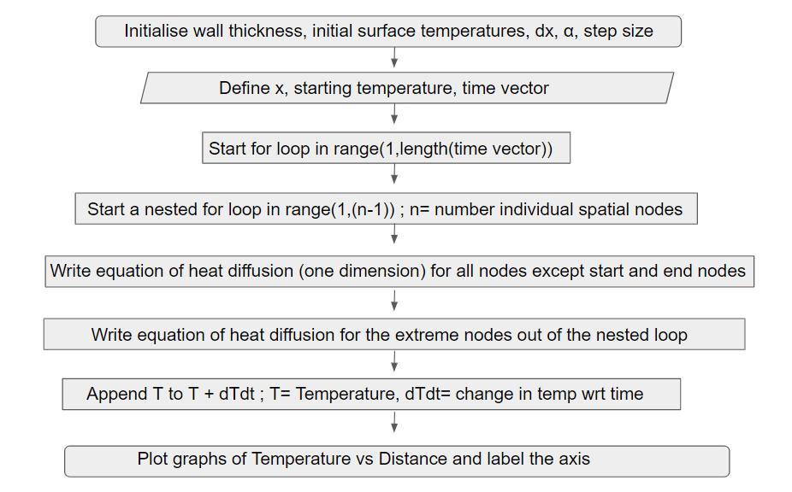

**CODE:**

# 

# **RESULT**

The following are the dynamic T(temperature in degree celsius) versus x(distance of a node from the end in metres) curves that were obtained as a solution of the second order one dimensional heat diffusion equation:

T(1) =50°C, T(2) =10°C



T(1) =40°C, T(2) =40°C



T(1) =40°C, T(2) =20°C



T(1) =40°C, T(2) =0°C



# **APPLICATIONS**

The heat diffusion equation is applied in a wide variety of fields ranging from image processing to mathematical biology. Industrially, it is used to find out how heat will diffuse through various polymers provided we know their coefficient of diffusivity or conversely, it will enable us to calculate the coefficient of diffusivity of a polymer provided we have the data of heat diffusion. Being a partial differential equation, the analytical solution of this heat diffusion equation also gives us a firm footing to understand the shape of various models & detecting its edges. Further, the famous Black–Scholes option pricing model's differential equation can be transformed into the heat equation allowing relatively easy solutions from a familiar body of mathematics. Also, the equation describing pressure diffusion in a porous medium is identical in form with the heat equation and this enables us to use analogous methods of solution for the same.

# **CONCLUSION**

From the Euler analysis of the one dimensional thermodynamic system we observe the nature of heat diffusion with respect to time, with no generation of energy and constant thermal conductivity. The various heat vs distance dynamic curves indicate how the heat diffusion is affected when the surface temperatures at the ends are varied. Thus, we also observe how such one dimensional systems achieve thermodynamic equilibrium. These observations provide analytical insight into physical phenomena like conduction and other heat transfer in one dimension and find a wide range of applications as elucidated above.

# **REFERENCES**

1. MIT. (n.d.). *Theory*. The 1-D heat diffusion. <https://ocw.mit.edu/courses/mathematics/18-303-linear-partial-differential-equations-fall-2006/lecture-notes/heateqni.pdf>
2. TECS. (n.d.). *Theory*. Derivation of heat equation (diffusion equation). <https://www.tec-science.com/thermodynamics/heat/heat-equation-diffusion-equation/>
3. Wikipedia. (n.d.). *Heat diffusion equation*. heat equation. <https://en.wikipedia.org/wiki/Heat_equation>